CS 255 System Design Document

UML Diagrams

UML Use Case Diagram
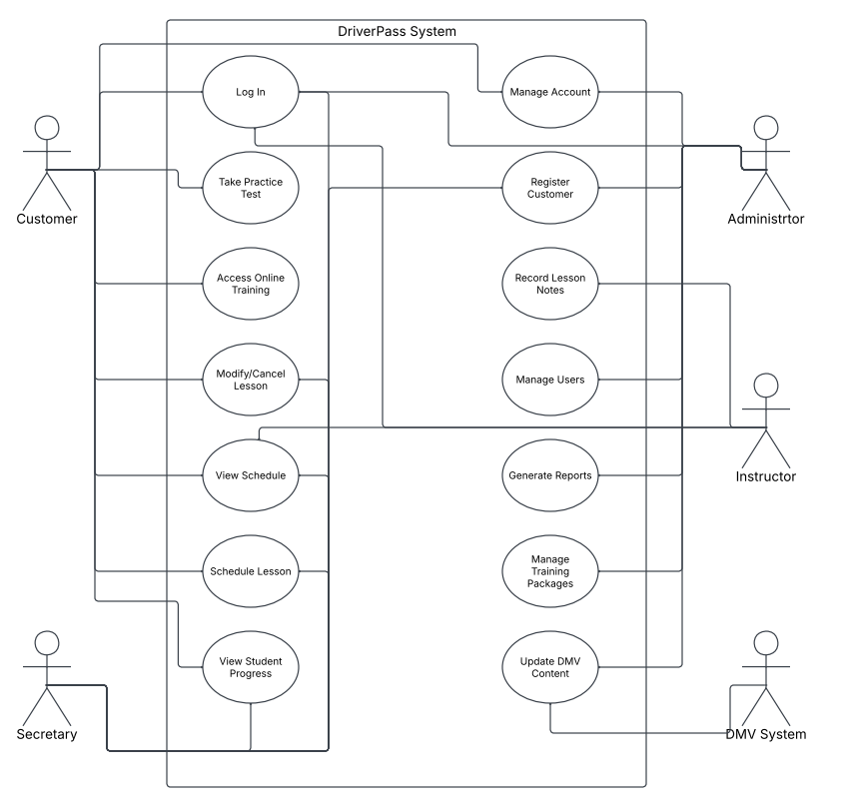

UML Activity Diagrams
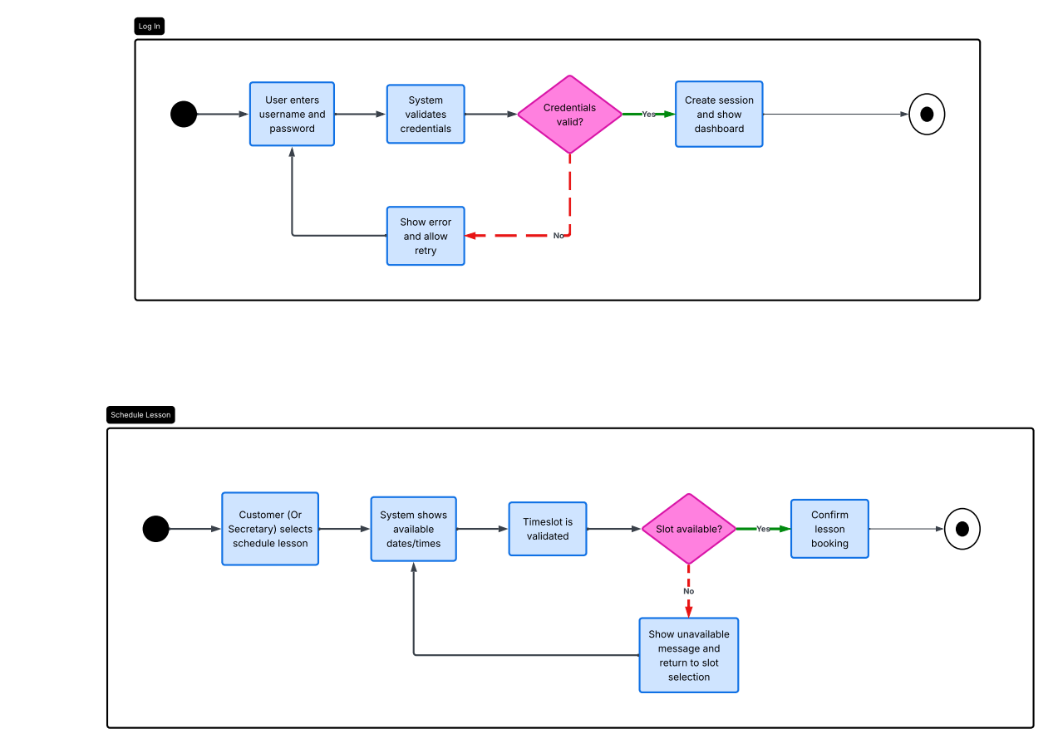

UML Sequence Diagram
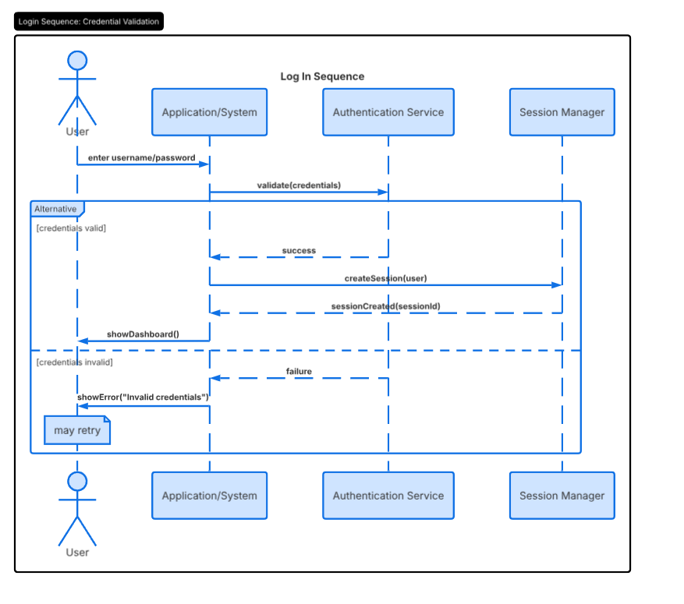

UML Class Diagram
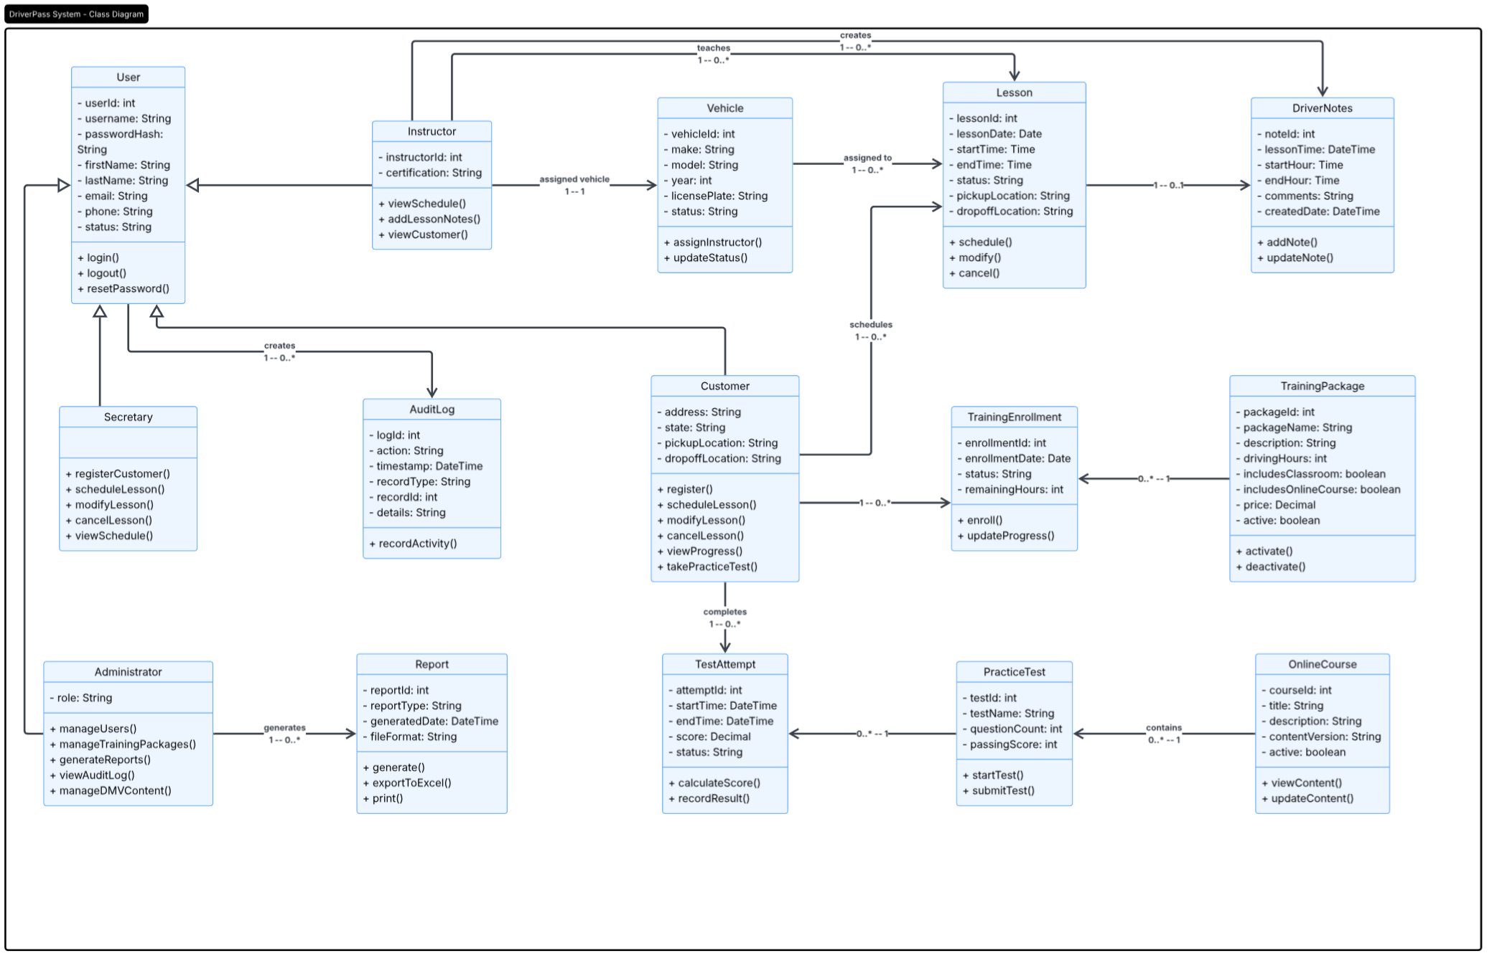

Technical Requirements
The DriverPass system will require a cloud-based web application that can be accessed securely from computers and mobile devices. The system will need the hardware, software, development tools, and infrastructure necessary to support customer accounts, lesson scheduling, online courses and practice tests, payments, reporting, and administration.

Hardware Requirements
- Client Devices: Customers and employees must be able to access the system using desktop computers, laptops, tablets, or smartphones of which are connected to the internet
- Employee Computers: DriverPass employees will need internet-connected computers for managing customer information, reservations, reports, and administrative tasks
- Cloud Server Infrastructure: The system will be hosted in a cloud environment rather than requiring DriverPass to maintain physical application servers

Software Requirements
- Web Application: The system will be developed as a browser-based application that does not require users to install specialized software, supporting current versions of commonly used desktop and mobile web browsers
- Database Management System: A secure relational database management system will store and manage customer, employee, reservation, vehicle, instructor, package, payment, training, test, and account information
- Authentication and Authorization: The system must provide secure user authentication, password recovery, account protection, and role-based authorization
- Payment Processing: A secure third-party payment processor will process customer payments without unnecessarily storing sensitive credit card information
- Scheduling Controls: The system must prevent double-booking of instructors, vehicles, and lesson time slots when creating or modifying reservations
- Reporting and Export Tools: The system must generate scheduling, student-progress, and system-activity reports and allow applicable information to be exported for use
- Notification Services: The system should support notifications for password recovery, appointment-related events, and important system or training-material updates
- Audit Logging: The system must record who created, modified, or canceled reservations and other significant administrative actions

Development and Design Tools
- Development Environment: Developers will need an IDE or code editor for building and maintaining the web application
- Version Control: Version-control software will be used to manage source code and track development changes
- Database Tools: Database design and management tools will be used to create, test, and maintain the system database
- Testing Tools: Browser, software, security, and performance testing tools will be used to verify that the system functions correctly across supported devices and browsers
- Documentation Tools: UML and diagramming tools will be used to document system architecture, processes, and design

Infrastructure Requirements
- Cloud Hosting: The system will require cloud-based application hosting, database hosting, and storage
- Secure Data Storage: Customer, appointment, training, test, account, and audit information must be stored securely
- Backup and Recovery: Automated backups and recovery capabilities must protect system and business data from accidental loss or system failures
- Network Security: HTTPS/TLS encryption, firewalls, and other cloud security controls must protect data and system communications
- Monitoring and Logging: The infrastructure must provide system monitoring, error logging, and activity logging so administrators can identify failed updates, errors, and operational issues
- Scalability: Cloud storage and computing resources should be scalable to support growth in customers, appointments, training materials, test results, and reports
- External Integrations: The system must support integration with the payment processor and other services needed to support notifications and updates to training materials when DMV rules, policies, or requirements change

Overall, the technical environment must provide DriverPass with a secure, reliable, and scalable system while minimizing the amount of infrastructure maintenance required from DriverPass employees.

